 School Counseling Program Newsletter
Shandrai Silva, School Counselor | December 2016

Counselor Message  Happy December! It is hard to believe so much of the school year has already passed and we are quickly approaching winter break. During November, the school counseling program offered classroom guidance lessons in Digital Citizenship, gratitude, listening to our hearts, and including others as we continue to focus on maintaining a respectful & bucket filling school environment. As a school, we participated in another school-wide service project by collecting food for a local food pantry. We collected over 2600 food items! See a couple pictures below. Thank you so much for supporting this effort.  Small group counseling is underway as students focus on coping skills, self-awareness and leadership skills.  We’re looking forward to the exciting opportunities ahead as we approach the 2nd half of the school year.  _______________________  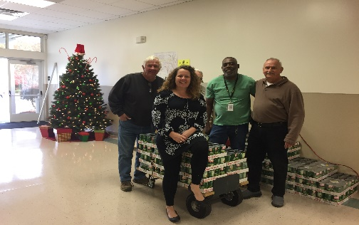  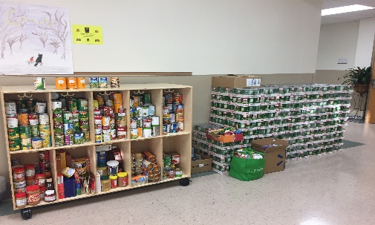 | Home of the Hawks    GCS Day of Kindness  December 6th- Wear pink to  show your commitment to  kindness & make an effort to  to be extra kind on this day.  How to see the school counselor  Classroom guidance classes are weekly based on grade level specials schedule. Small group counseling and individual counseling by self -referral, parent referral, teacher referral, administrator referral or counselor initiated.  Contact School Counselor at 704-866-8467or sosilva@gaston.k12.nc.us.   | Character Education  “We’re Soaring with Good Character”  ______________________________  The character trait of the month is Kindness. Kindness is being caring and showing concern and compassion for others.  ______________________________________________  Promoting Character Education  Living Generously: 5 Tips for Families  Ways your family can practice kindness and compassion this season:  - Volunteer together: do a special holiday service project together or practice kindness towards friends, neighbors and the community.  - Give What You Get: For each gift you receive this holiday season, make it a new tradition to give one gift back. Your “gift” can be anything, from volunteer time to a hug, a special card, a sweet treat.  - Know What You Need: Take time as a family to go through gently used clothes, books and toys and donate them.  - Be Thoughtful: Be a thoughtful giver- find out about unmet needs in your community and give to meet those specific needs.  - Make it a Priority: Make giving back an important part of your family’s priorities. Do it regularly. Put giving on your family’s calendar.  http://blog.volunteerspot.com/volunteer_guru/volunteering_at_church/#axzz3t7fVQP8S

